1.For PC Com Port Communication Check Com Port Number for PC using Hercules Software

2.First Install TF6340 in Target & XAE system

3.Confirm the com port number (must be Com 1,2,3,4) others are not supported

4.Add serial port in I/O

5.Port should be same as step 1

6.Com Port Mode setting for pc, make sure receiver & Device manager com setting are same as setting in twincat

8.Create 2 Task one for Standard Program & another one for communication make task time is less usually 2ms (Refer manual for further information) & add reference TC2_SerialCom

9.Create an BackgroundCommProgram(PRG) call it in CommTask

10.In Back Ground Program Add following Variable

(* I/O variables for a PC-COM port *)

stIn_PcCom AT %I* : PcComInData; (* linked to the port in the TwinCAT System Manager *)

stOut_PcCom AT %Q* : PcComOutData; (* linked to the port in the TwinCAT System Manager *)

(* I/O variables for a EL6001 terminal*)

stIn_EL6001 AT %I* : EL6inData22B; (* linked to the EL6001 in the TwinCAT System Manager *)

stOut_EL6001 AT %Q* : EL6outData22B;(* linked to the EL6001 in the TwinCAT System Manager *)

(* I/O variables for a KL6001 terminal*)

stIn_KL6001 AT %I* : KL6inData; (* linked to the KL6001 in the TwinCAT System Manager *)

stOut_KL6001 AT %Q* : KL6outData; (* linked to the KL6001 in the TwinCAT System Manager *)

11.Add Global Variable for Buffer

(* Buffer Variable *)

RxBufferPcCom : ComBuffer; (* Receive data buffer; used with all receive function blocks *)

TxBufferPcCom : ComBuffer; (* Transmit data buffer; used with all receive function blocks *)

12.Link Background I/O Variable to Hardware

13.Go to com device click on input, select data1 to 64 Right click change multilink & link the background created variable

Similar to output also

14. Go to Instance, Task Inputs servStatus to com input device, similar for output

15.Also add serStatus & SerCtrl

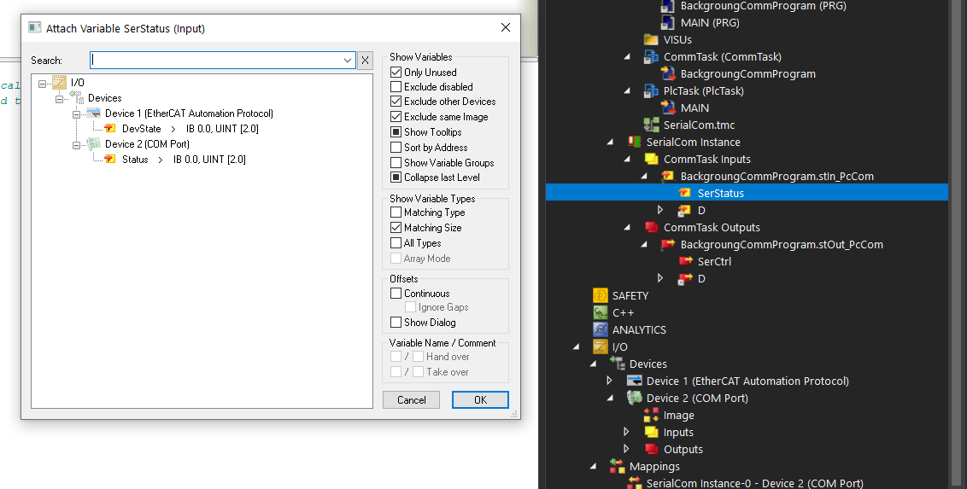

16.Add following Program in Background Program

fbPcComCtrl(

Mode:= SERIALLINEMODE_PC_COM_PORT,

pComIn:= ADR(stIn_PcCom),

pComOut:= ADR(stOut_PcCom),

SizeComIn:= UINT_TO_INT(SIZEOF(stIn_PcCom)),

Error=> ,

ErrorID=> ,

TxBuffer:= SerialComm.TxBufferPcCom,

RxBuffer:= SerialComm.RxBufferPcCom);

IF fbPcComCtrl.Error THEN

bPcComCtrlError := TRUE;

ePcComCtrlErrorID := fbPcComCtrl.ErrorID;

END_IF

17.In Main Program

Variable

fbSerialCommInstance1 : SerialCom;

sRecieveString : STRING;

bRecieveError : BOOL;

bSendBusy: BOOL;

eSendError: INT;

sSendData : STRING;

bsendTrigger: BOOL;

STxBuffer: INT;

tSendTime: INT;

sizeoff : UINT;

bRecieveReset: BOOL;

(* Send String Data *)

fbSerialCommInstance1(bSendData:= bsendTrigger,

bReset := bRecieveReset,

TxBuffer := SerialComm.TxBufferPcCom,

sSendPrefix:='$01',

sSendSuffix:='$02',

sSendString:=sSendData,

bSendBusy =>bSendBusy,

eSendError =>eSendError,

RxBuffer := SerialComm.RxBufferPcCom,

sReceiveString =>sRecieveString,

sReceivePrefix:='$01',

sReceiveSuffix:='$02',

tReceiveTimeOut := T#1S,

bReset :=bRecieveError,

bReceiveStringData =>,

bReceiveBusy =>,

eReceiveError =>,

bReceiveTimeOut =>

);

18.Then in Main Send sting with sSendData Input variable & once we recieved an string will be displayed in sRecieveString

19 Github Link https://github.com/gokulgbeckhoff/SerialCommunication